12. Demonstrate virtualization by Installing Type-2 Hypervisor in your device, create and configure VM image with a Host Operating system (Either Windows/Linux), using VMware workstation.

Aim :

To demonstrate virtualization by installing a Type-2 Hypervisor (VMware Workstation) on the host system and to create, configure, and run a Virtual Machine (VM) with a guest operating system (Windows/Linux).

Procedure :

- Enable hardware virtualization (Intel VT-x / AMD-V) in the system BIOS.
- Download and install VMware Workstation on the host operating system.
- Download the ISO file of the guest operating system (Windows or Linux).
- Open VMware Workstation and select Create a New Virtual Machine.
- Choose Typical (Recommended) configuration and select the guest OS ISO file.
- Specify the guest operating system type and version.
- Provide a name and storage location for the virtual machine.
- Allocate virtual disk space, memory (RAM), and CPU cores.
- Complete the VM creation and power on the virtual machine.
- Install the guest operating system by following on-screen instructions.
- Install VMware Tools inside the guest OS for improved performance.
- Restart the virtual machine and verify successful installation.

Output :

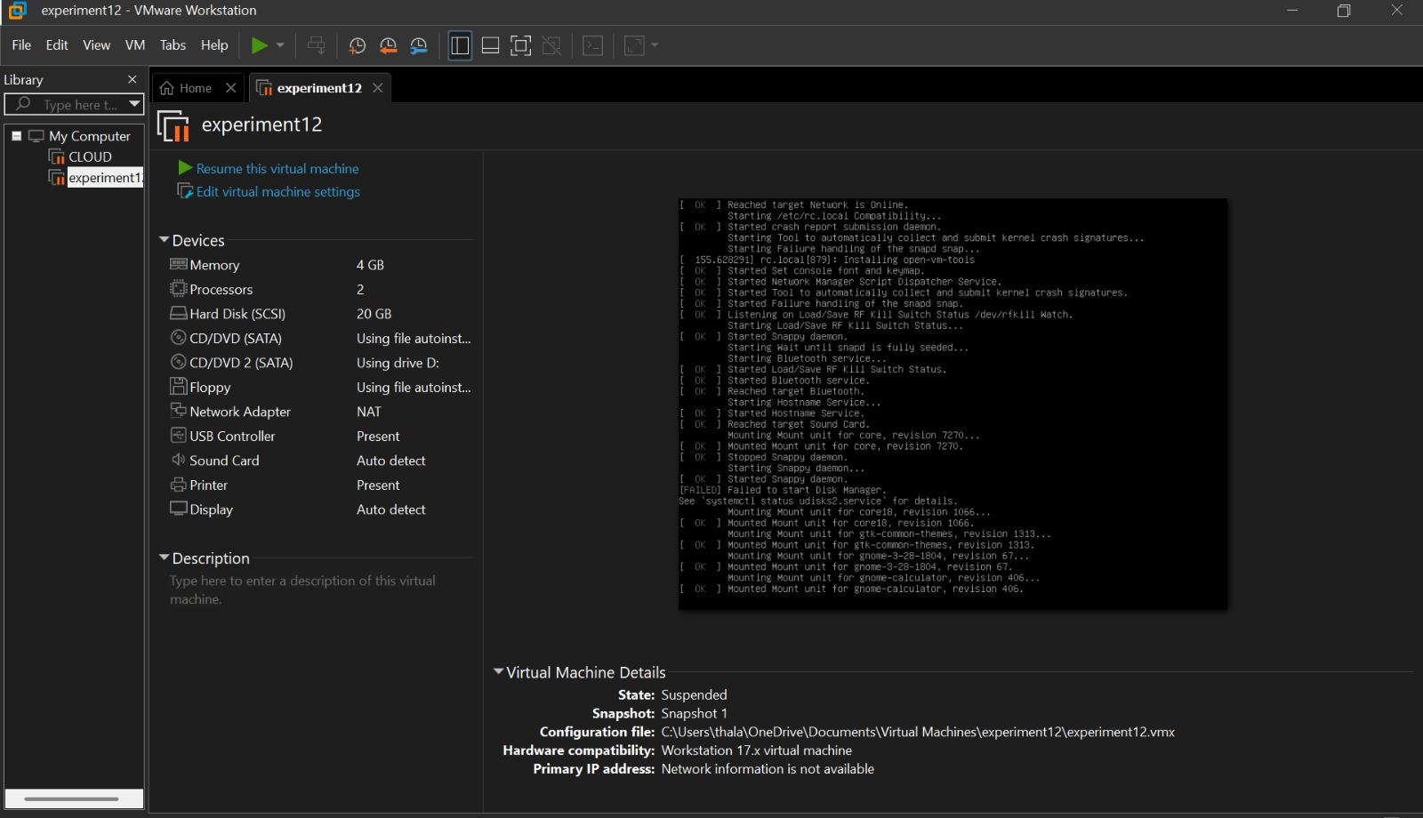
Result :

Virtualization was successfully demonstrated by installing a Type-2 Hypervisor (VMware Workstation) and creating and running a Virtual Machine with a guest operating system. The VM operated independently of the host system, confirming the effective implementation of virtualization.

